## Gradient Descent:

**Gradient descent** (GD) is an iterative first-order optimisation algorithm, used to find a local minimum/maximum of a given function. This method is commonly used in *machine learning* (ML) and *deep learning* (DL) to minimise a cost/loss function (e.g. in a linear regression).

It find the optimal parameters for an equation

*New param = old param – Learning rate * slope*

Here slope = first order derivative of cost function

GD stopes when slope is near to zero

# ADABOOST:

1. RF makes a series of trees, instead AB makes a series of stumps.
2. RF has equal vote on final classification, AB has different amount of say for each stump.
3. In RF each DT is made independent of the other, in contrast in AB each stump is made by taking the previous stump’s mistake into account.

In RF for sampling we use Bootstrap i.e. random selection of samples with replacement, there is no weight associated with the samples, In AB each sample is given some weight, in beginning all samples have equal weight for first stump to make and then after the weights are recalculated. First stump is selected based on least Gini impurity index.

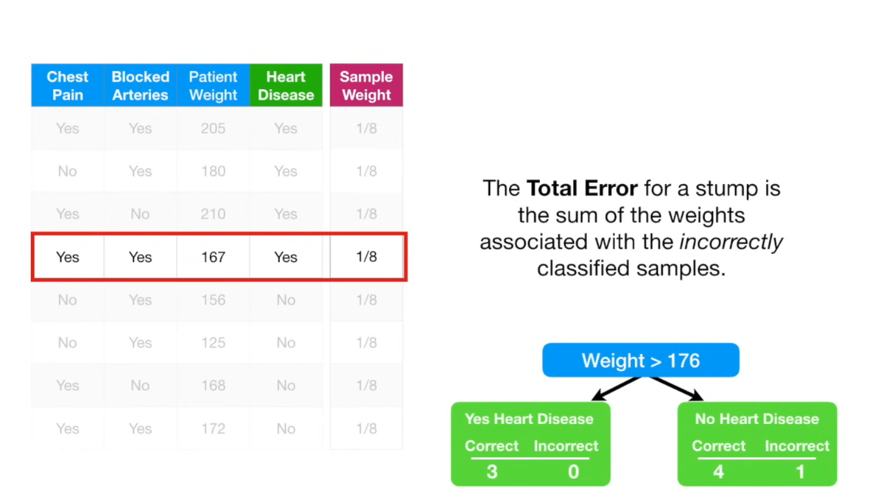

Because all the samples weights add up to 1total error will always be 0 for perfect stump and 1 for horrible stump. we use this total error to determine Amount of say this stump has in the final classification. 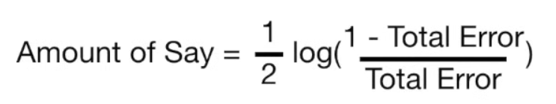

How much say each stump has on final classification is calculated on how well the stump classifies the samples. 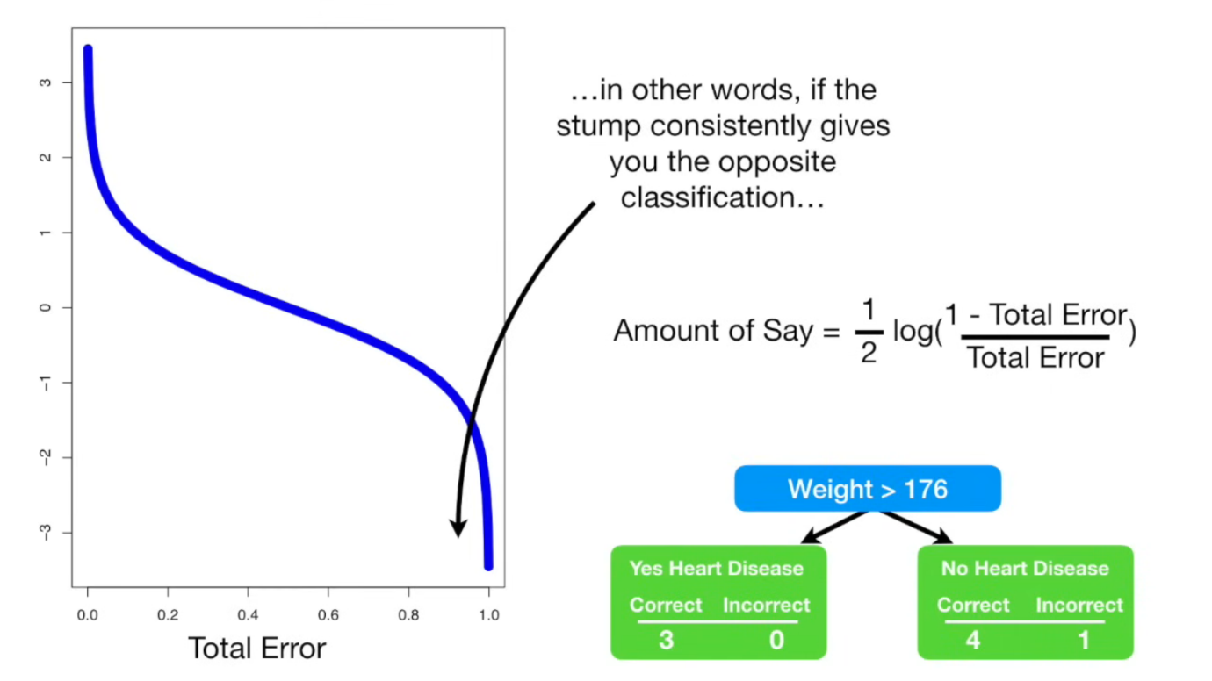

Now we need to modify the weights so that the next stump will take the errors that the current stump made into account. The below formula we will use to increase the sample weight for the sample that was incorrectly classified. And the other formula which has e^(-amount of say) instead of e^ (amount of say), decrease the sample weight for the sample that was correctly classified .After calculating new sample weights we normalize such that all sample weights add up to one.

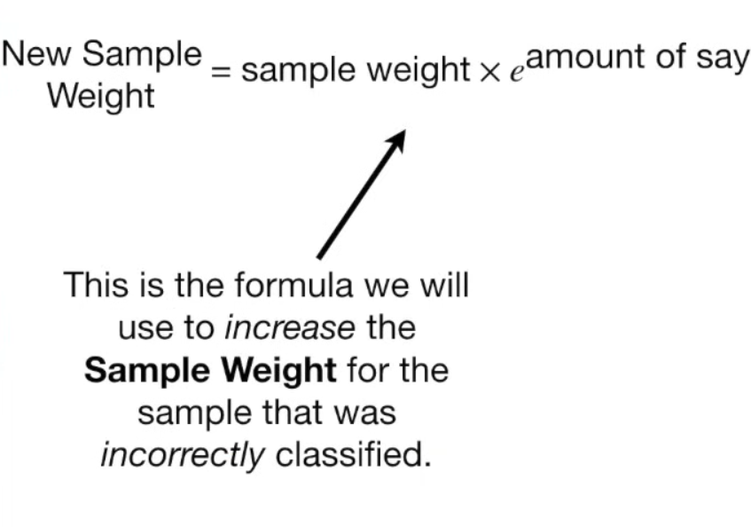

In theory, we could use the sample weights to calculate weighted Gini indexes to determine which variable should split the next stump. The weighted Gini index would put more emphasis on correctly classifying the misclassified sample by the last stump. Alternatively instead of using weighted gini index we can make a new collection of samples that contains duplicate copies of the samples with the largest sample weight. 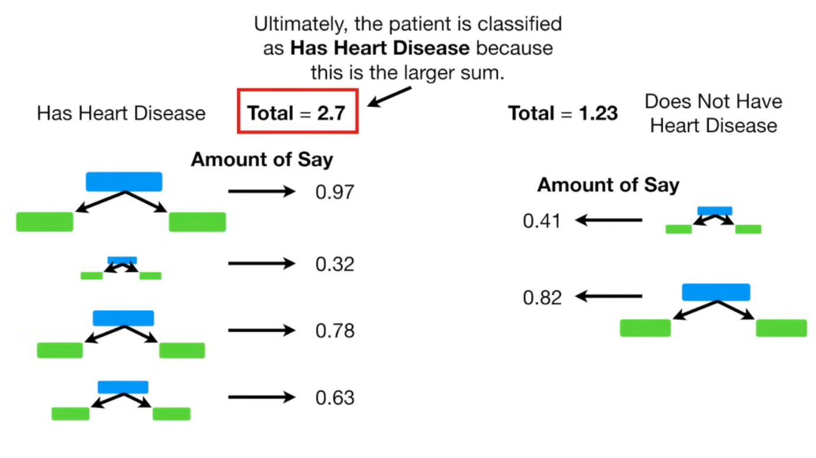

# Gradient Boost

Regression:

It first starts with a leaf (initial prediction is average). Then based on residuals it build a tree to predict residuals. So this predicted residuals multiplied by learning rate and added to initial predict. i.e. we scale the tree’s contribution to the final prediction with a learning rate. Here we use learning rate to reduce overfitting. Then we add other tree based on new residuals and we keep adding trees based on the errors made by the previous tree.

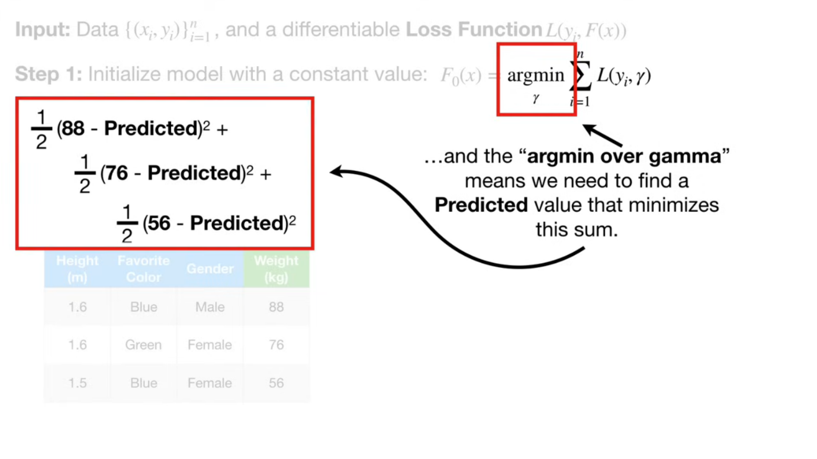

Here Yi = observed value

Gamma = predicted value

It finds for which value of the predicted value the loss function (sum of squared residuals) is minimum.so we get the initial predict value.

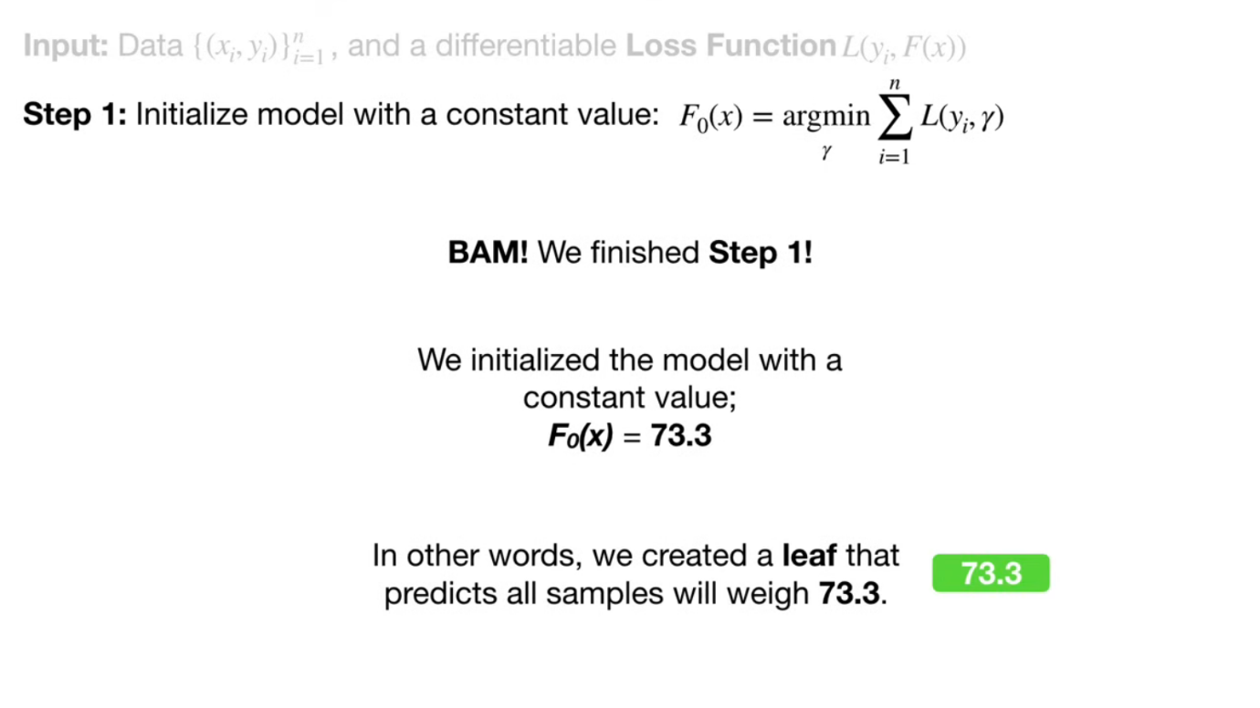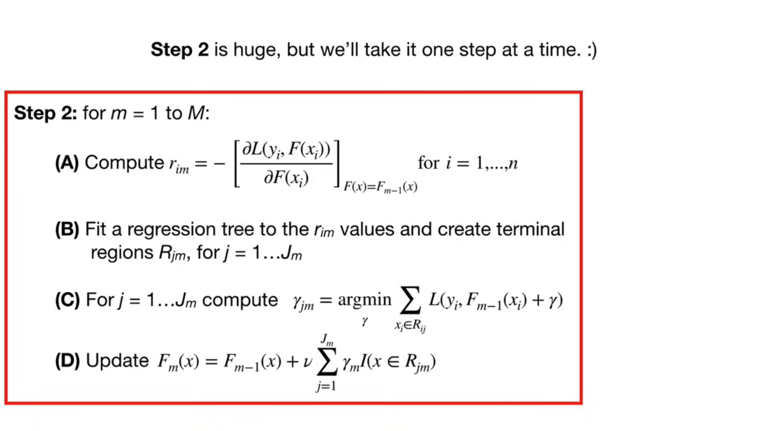

M = number of trees to be made

r = short form of residual , i = sample number , m = tree we are trying to build

r im = derivative of loss w.r.t predict

= we already calculated it that is Residual (observed - predict). It is residuals of all the samples. these are pseudo residuals

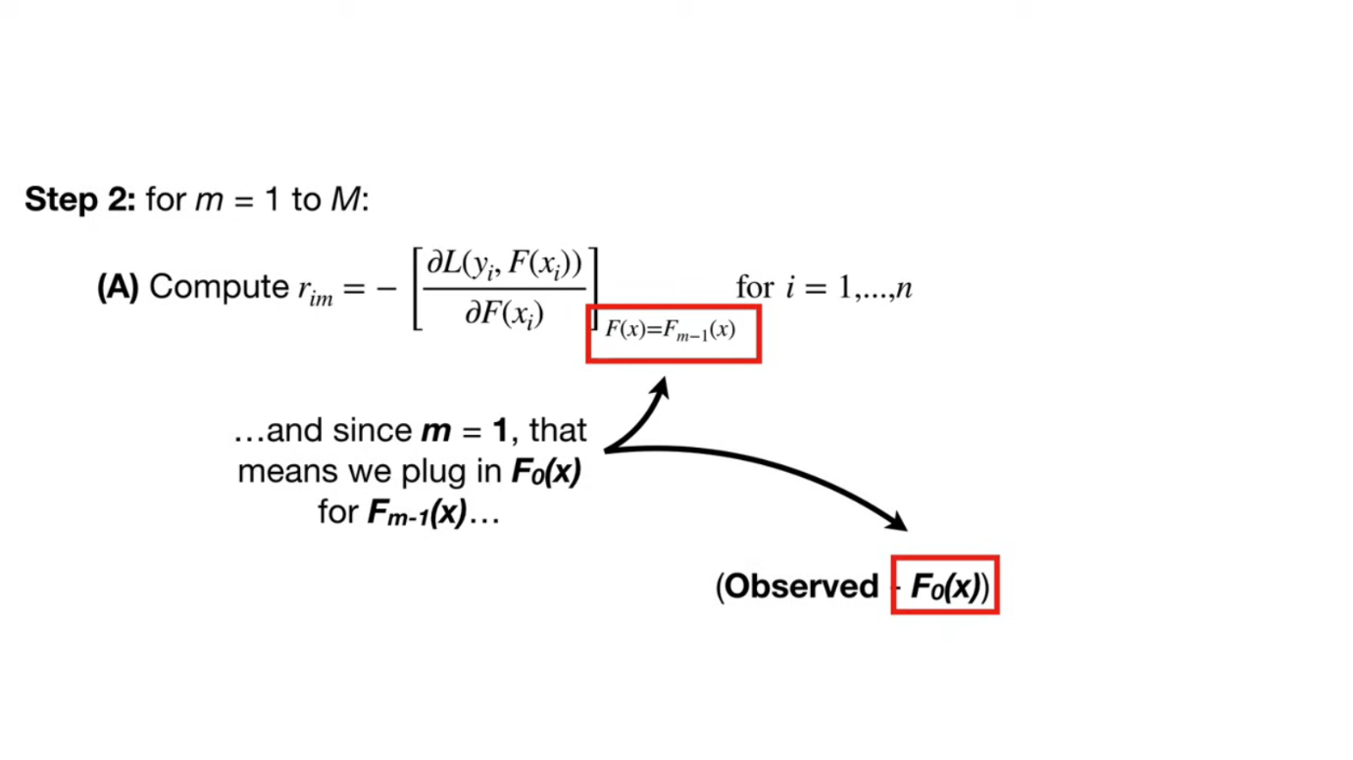

F0(x) is initial predict i.e. 73.3 . so now we calculate all pseudo residuals.

NOW step two we start Build a tree to predict a this calculated residuals instead of target variable value i.e. weight. 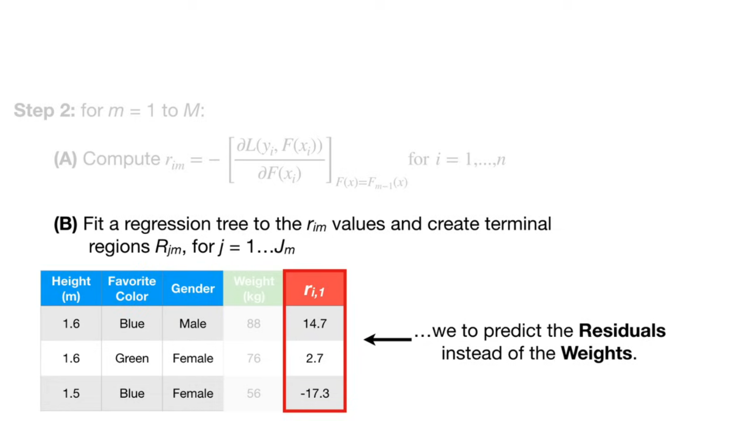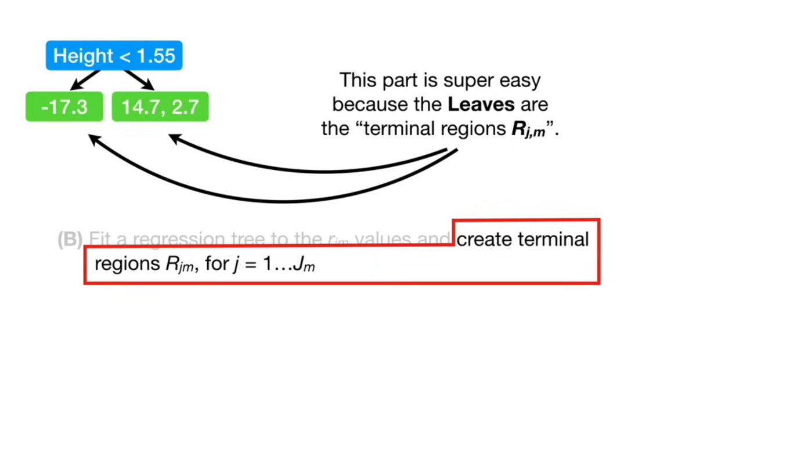j= index of each leaf in the tree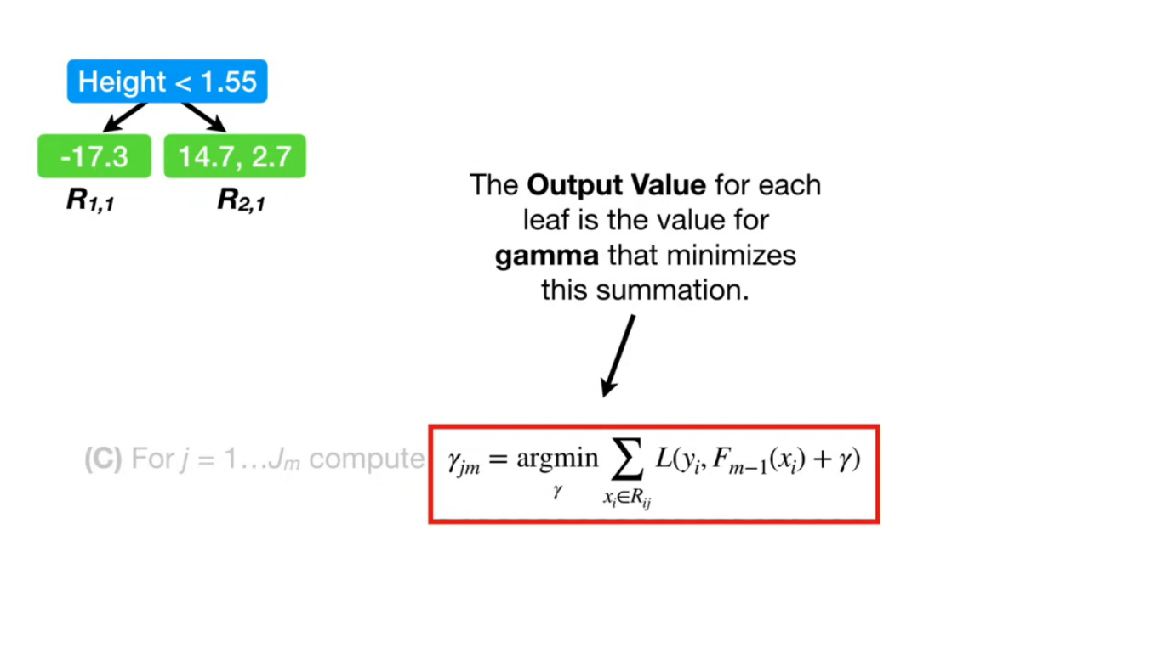since each leaf may contain many residuals we should find one residual per leaf that minimises above . here gamma is residual. So we find out he new residual that minimizes the loss.

finally calculate new prediction that updates initial prediction. so that we should find new residuals ,hence process repeates until the specified no of trees build i.e. M.

see the new term nu in part d calculation is learning rate.  
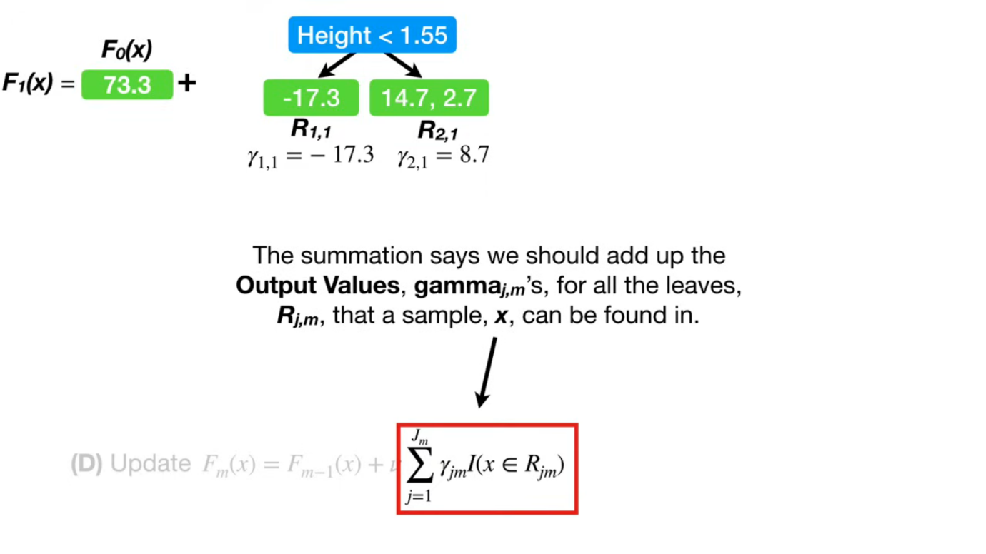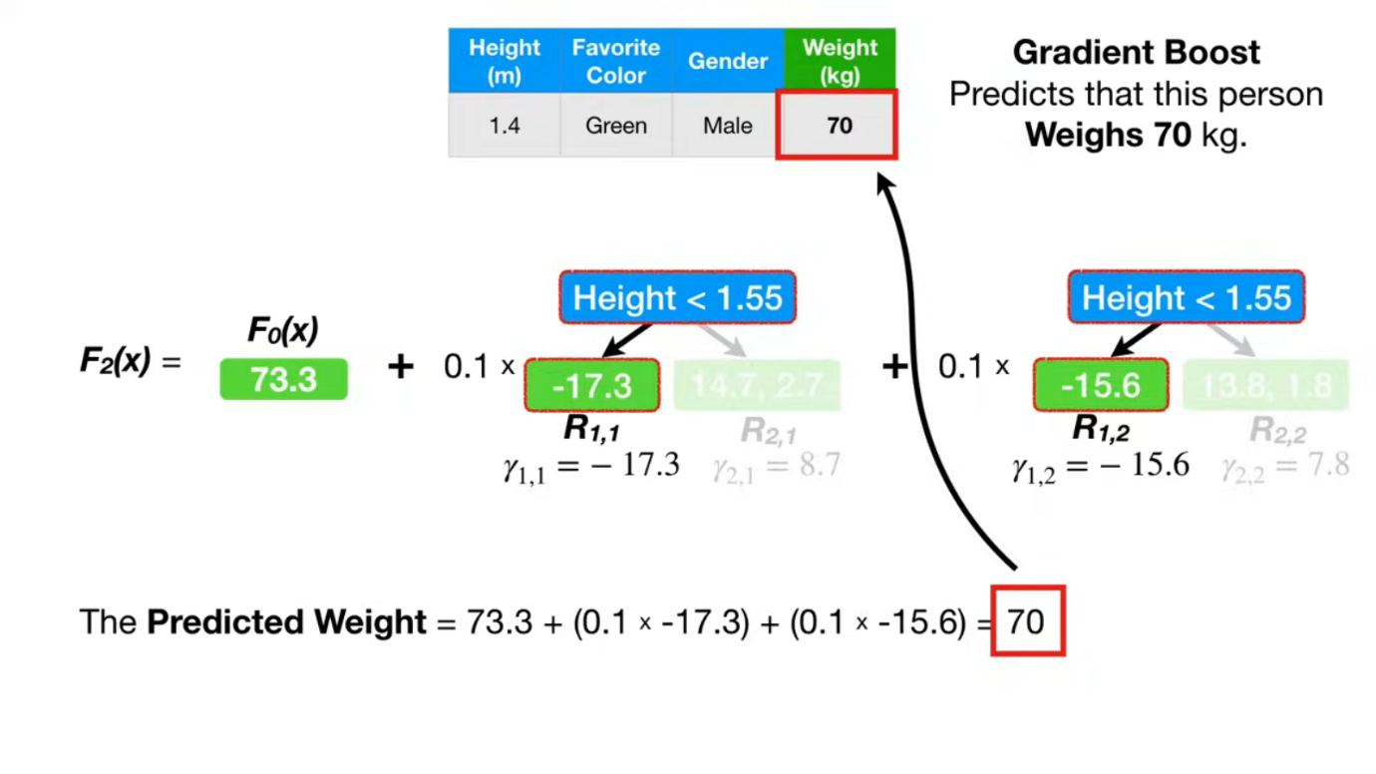

# GB Classification

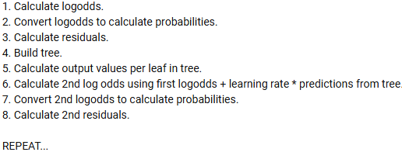

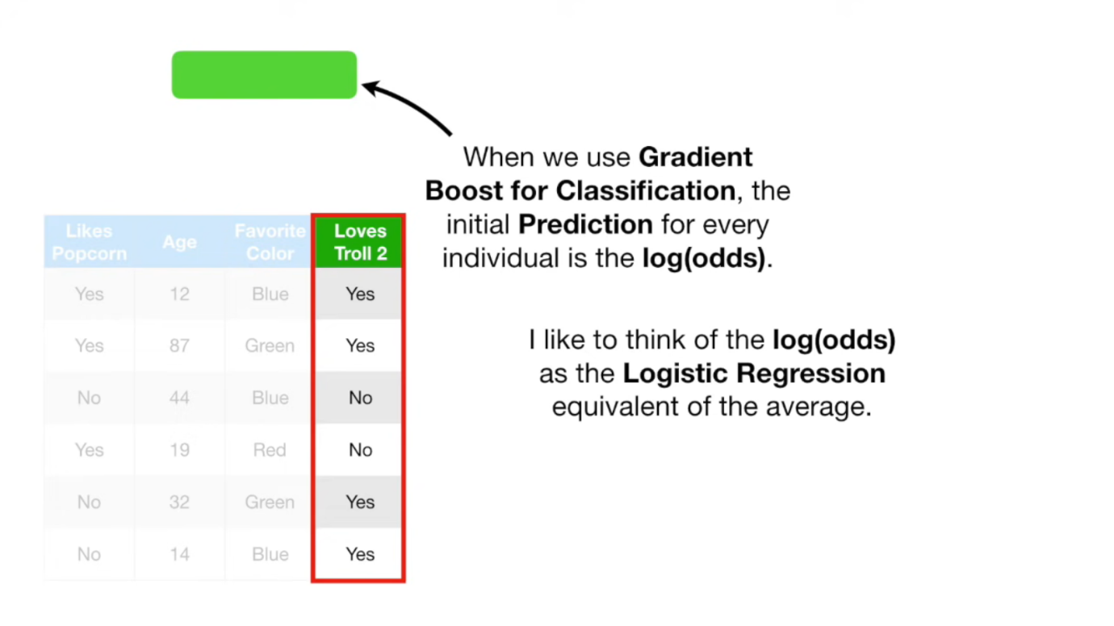

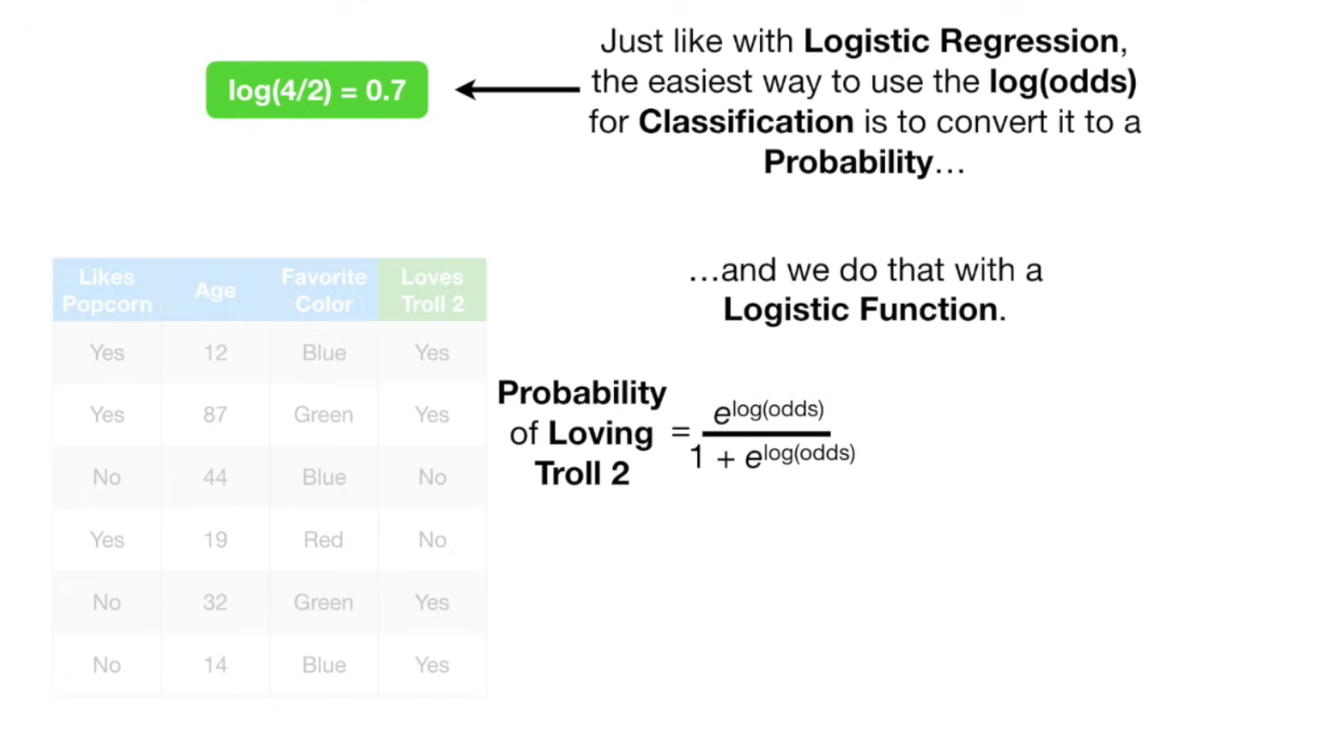

P= 0.7 (rounded value)= initial prediction (in this example log(odds) and probability got same value)

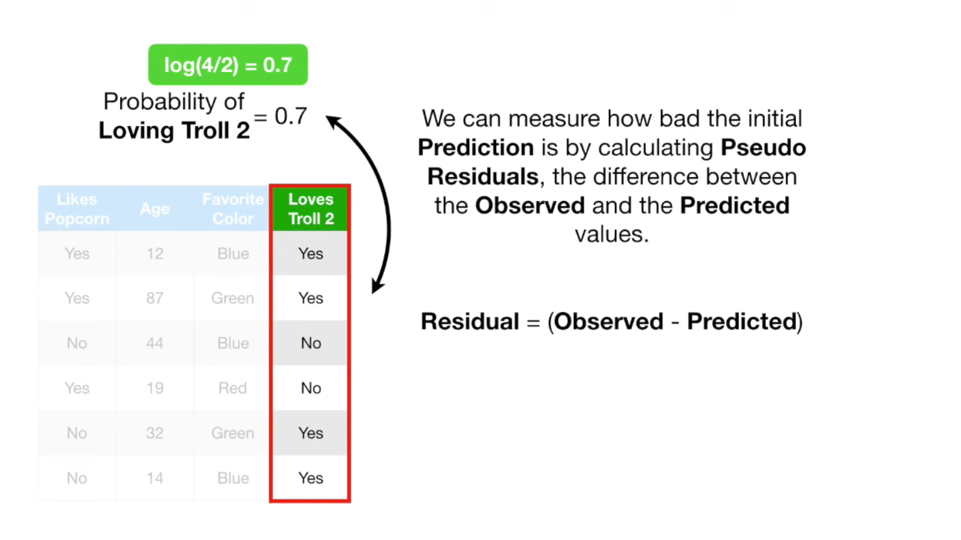

Now calculate pseudo residuals for the observations. and build a tree to predict the residuals. here one thing to keep in mind is in leaves we are predicting probabilities, but our initial predict is log of odds, so convert the leaves values using this below formula.

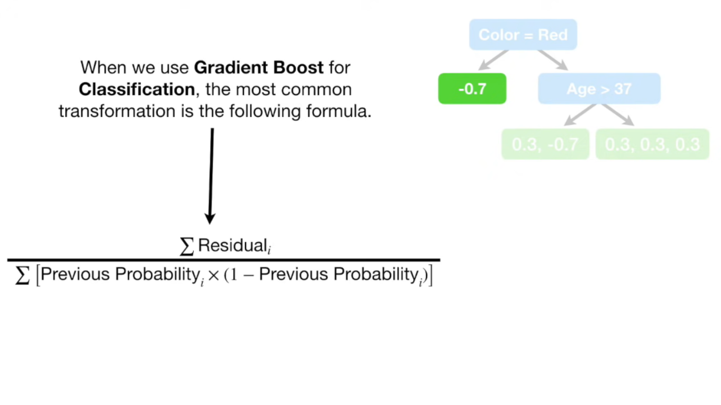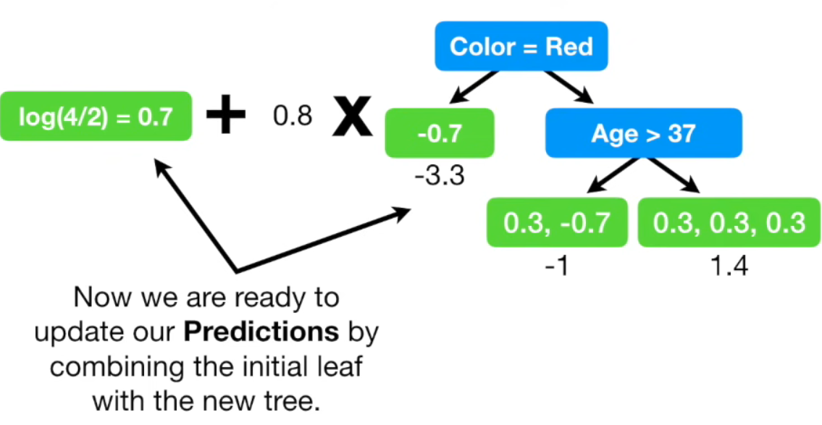Now we get new log(odd) value and this is our new predict so convert it to probability and again calculate the pseudo residuals and again build tree to predict residuals. Then convert leave output values to log(odd) then new prediction. we repeat this until the desired results occur.

**Now step by step explanation of formulas**

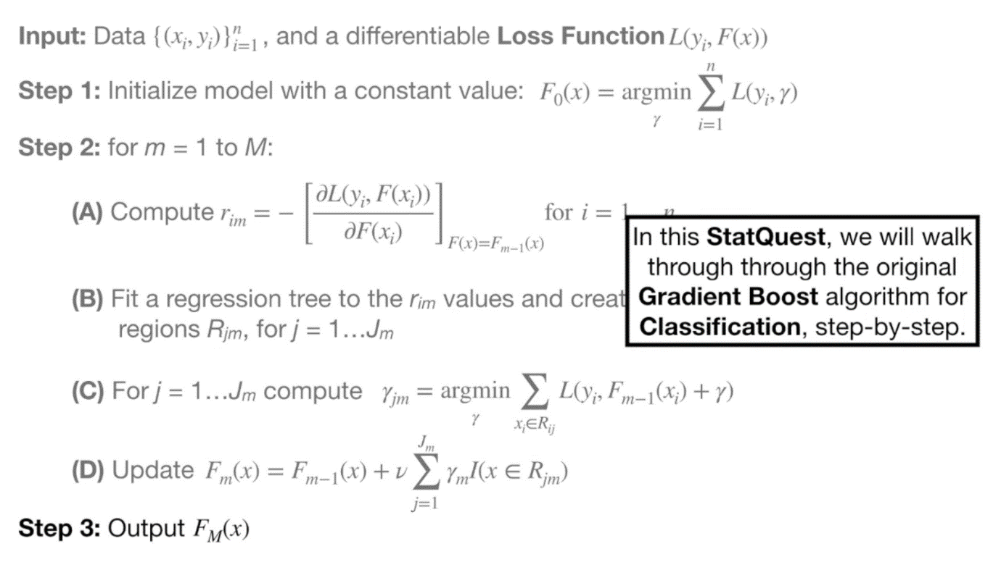first the loss function is same that we used in logistic regression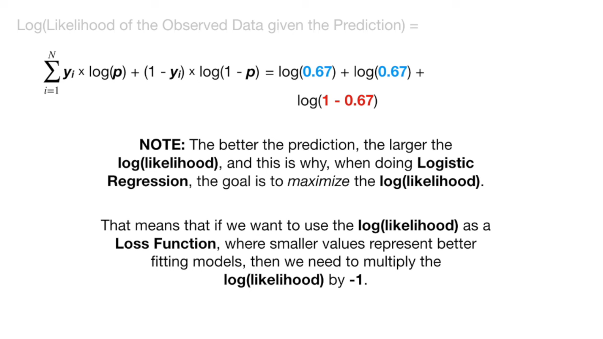now we predict initial prediction by setting the first order derivative of loss func to zero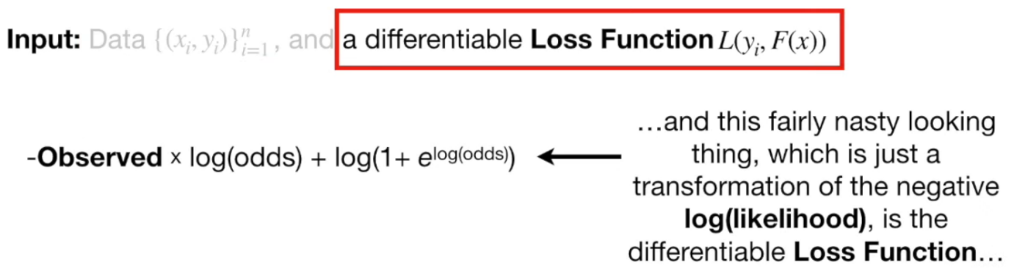

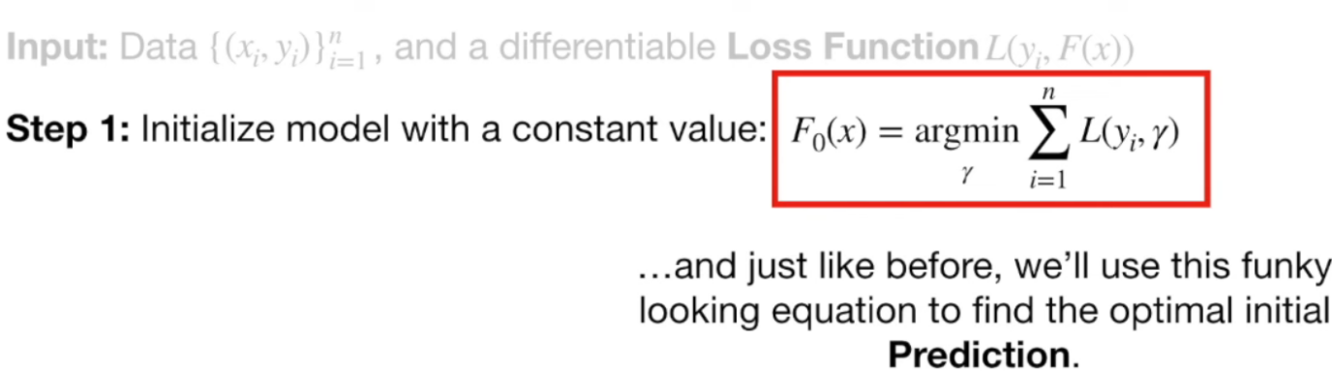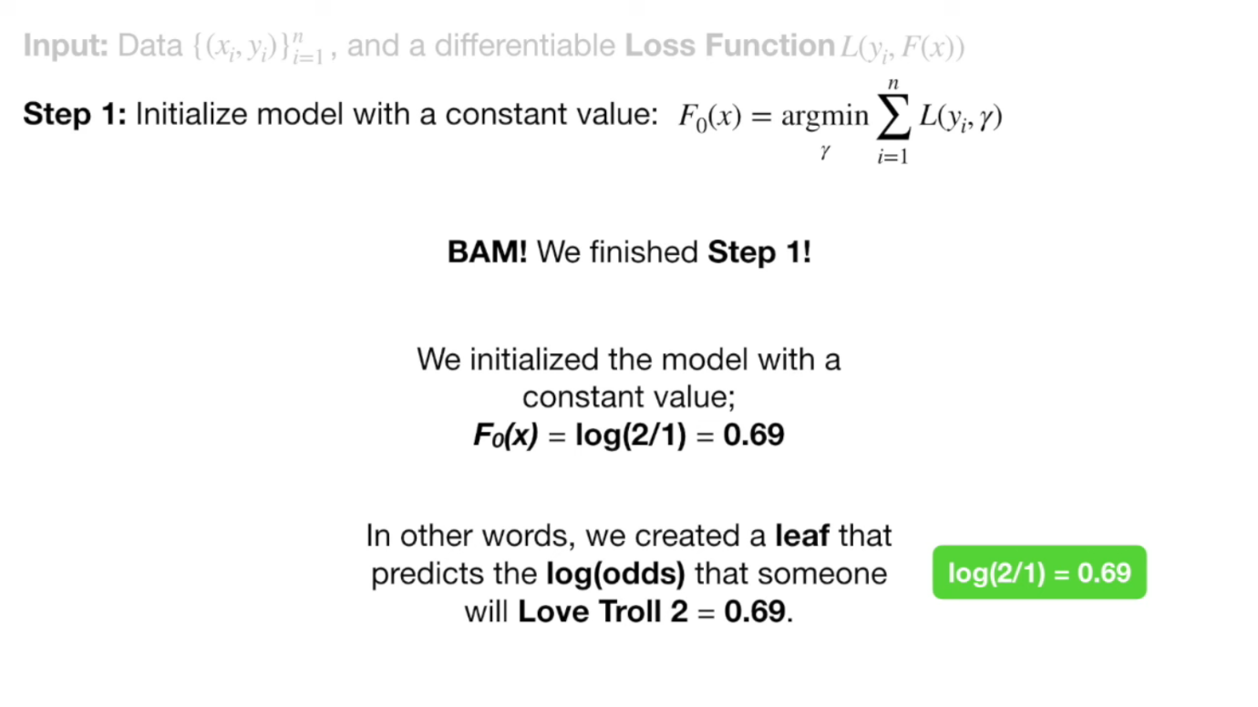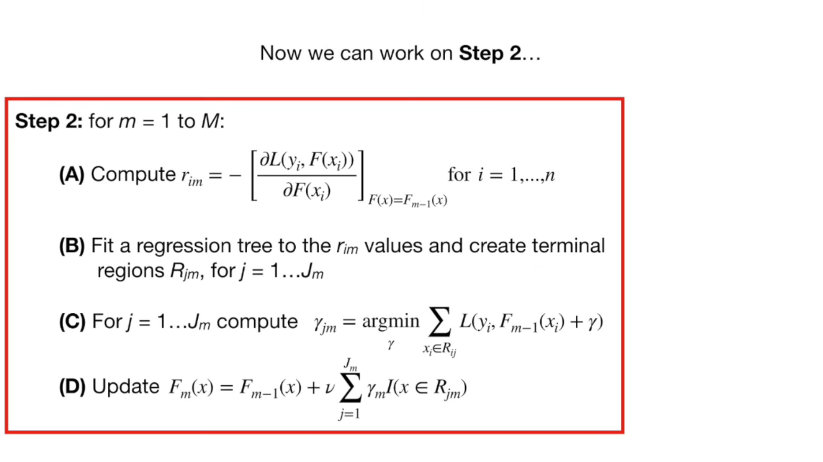here the first to calculate residuals, then next build a tree to predict residuals, next calculate output of each leaves. Update the initial predict and repeat the process until you get good results or required number of trees.

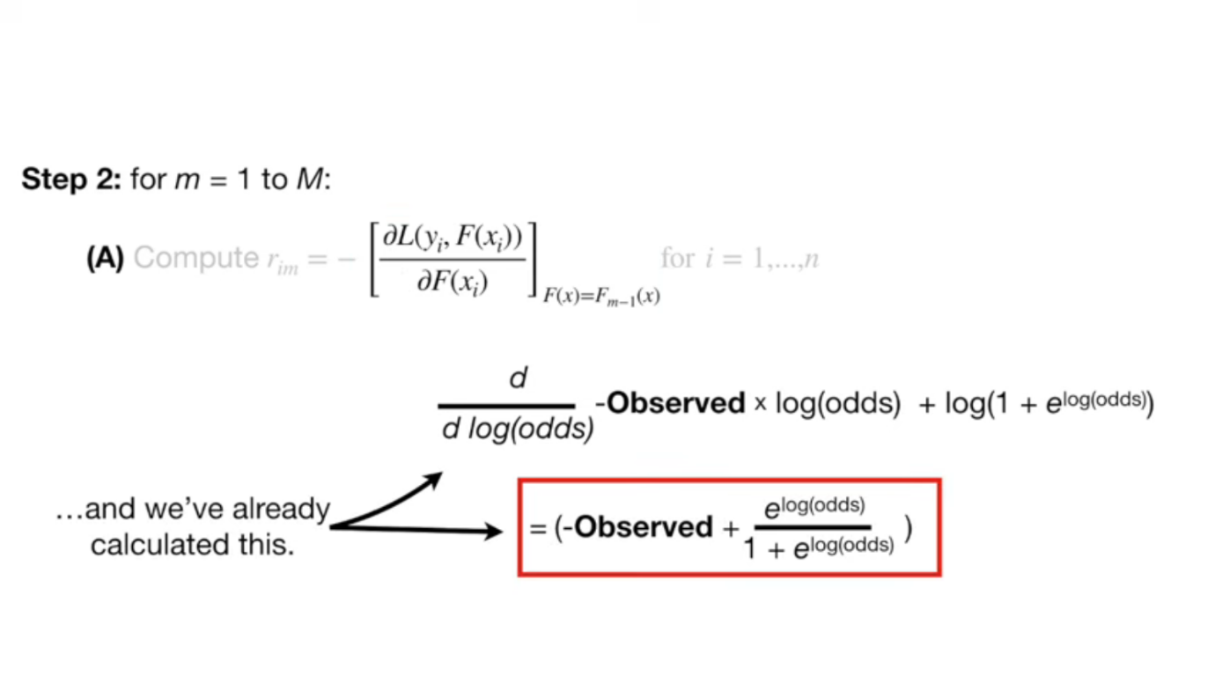

FINAL

# XGBOOST

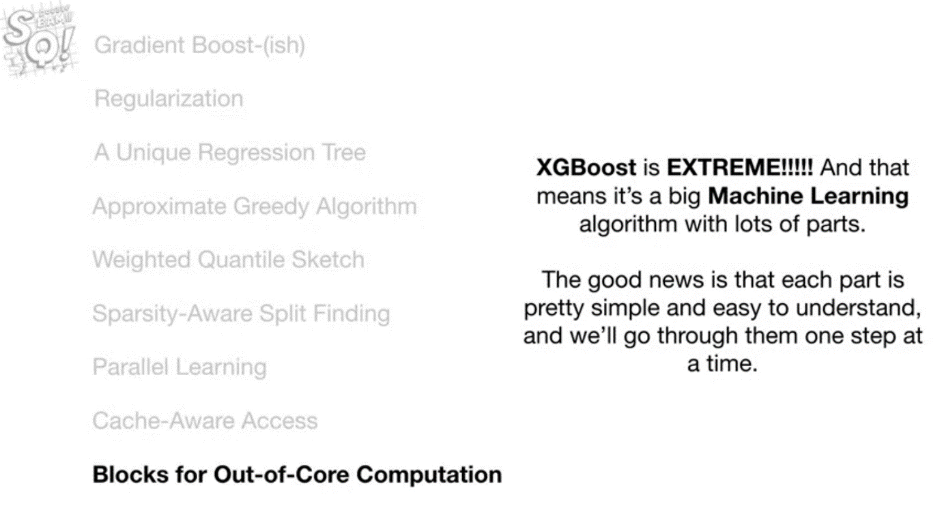

As it begins with a prediction of leaf with 0.5 either regression or classification.

Then it start build a unique tree starting with a leaf with residuals, and root nodes of different variables then calculate similarity scores of the node. Then calculate Gain from initial leaf and the nodes. Which node give highest gain that node will be selected as Root node. In below formula lambda is reg param which is intended to reduce the prediction’s sensitivity to individual observations. When lambda values > 0 then it is easier to prune leaves because the values for gain are smaller.

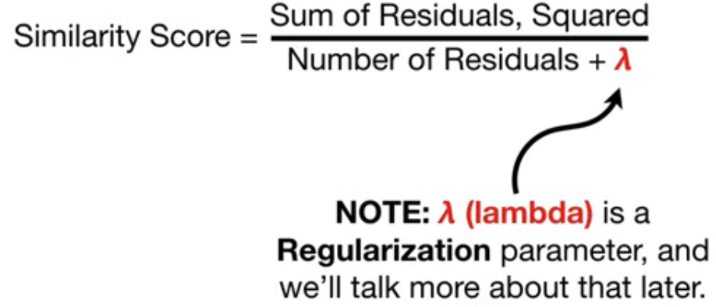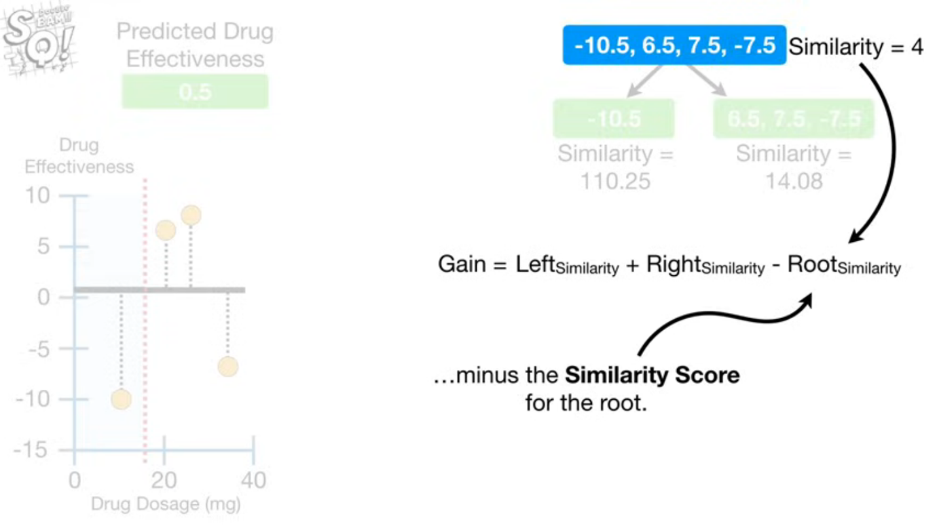

After building a tree we prune the tree based on gamma value (hyperparameter).

Now we calculate the output values for the leaves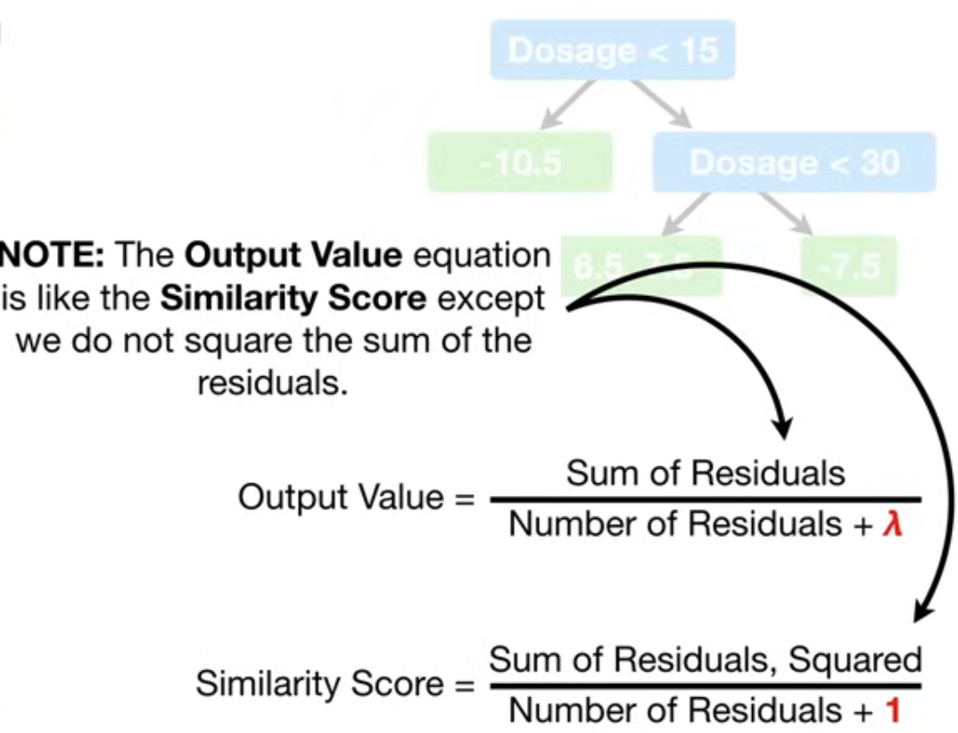

Now the prediction will be this nn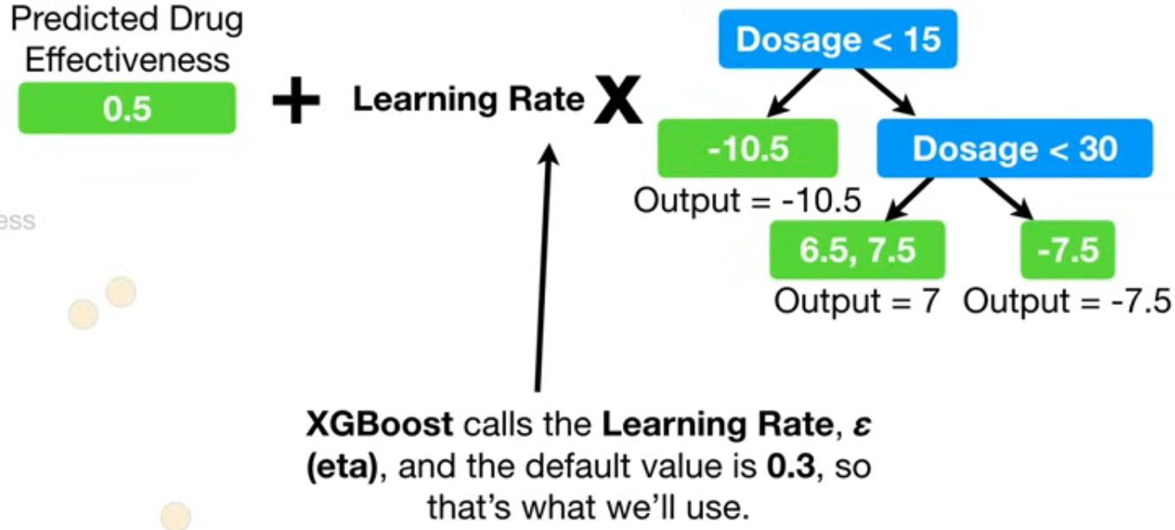

Now classification we use different formulas for similarity scores and output values of leaves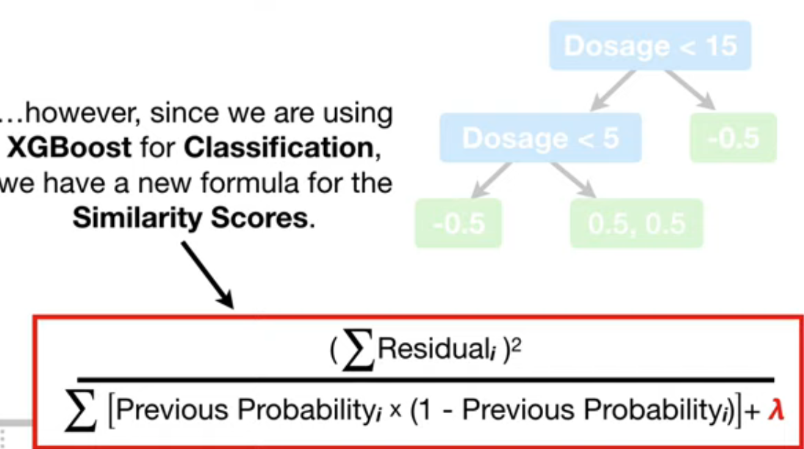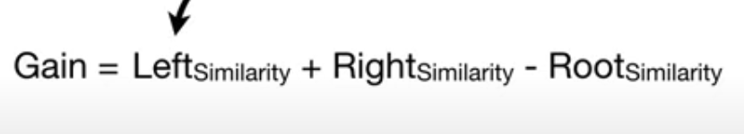

XGBOOST also have a threshold for the minimum number of Residuals in each leaf. that is called COVER. This is min_child_weight. We calculate cover value of leaf by below formula. The default value is zero for classification. If the cover value of leaf is less than the default value It will prune the leaf.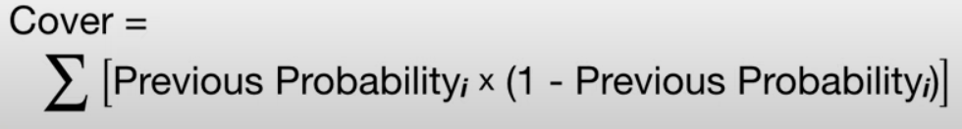cover = above formula – lambda.

Remember if lambda > 0 then regularization in action it will have small similarities scores and chance of pruning is high. 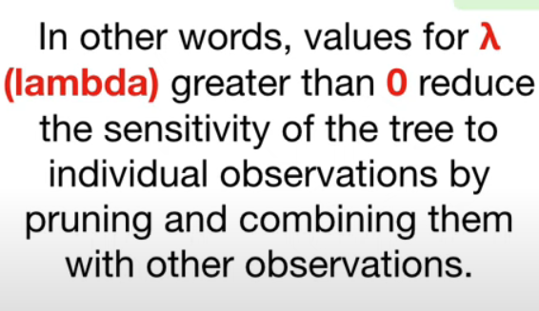

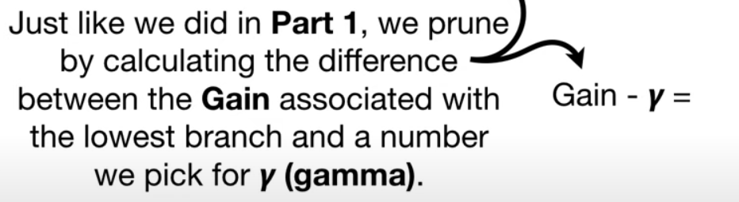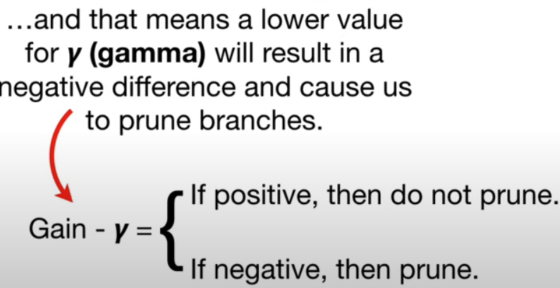

Now we calculate output values for a leaves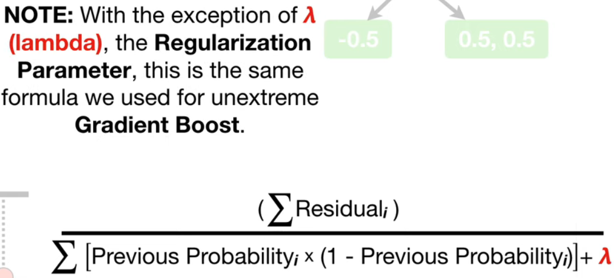Now convert the initial predict value to log of odds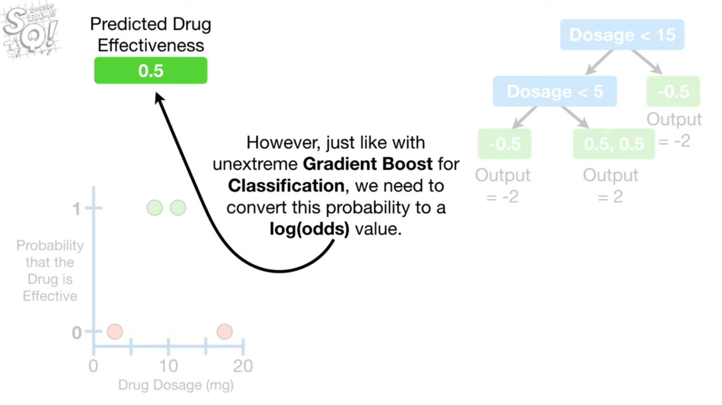Now new predict is ready .so again find residuals , build a tree process repeates

Initial prediction is multiplied by learning rate to the next predict. Since moving slowly (step by step) towards a right directions reduces the chances of overfitting.

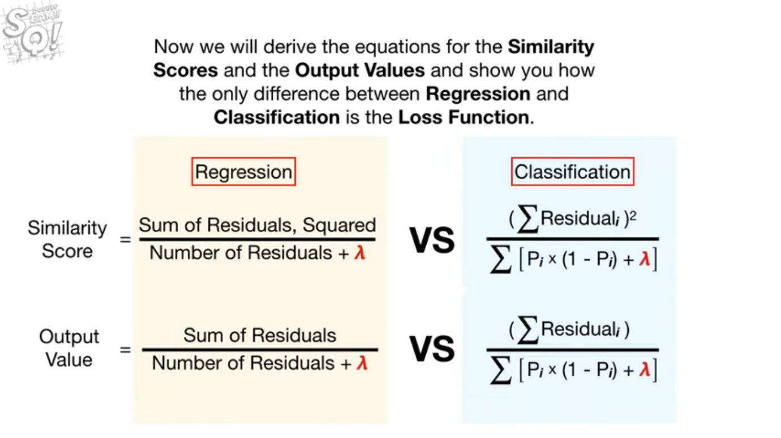

XGBOOST uses Ridge Regression for regularization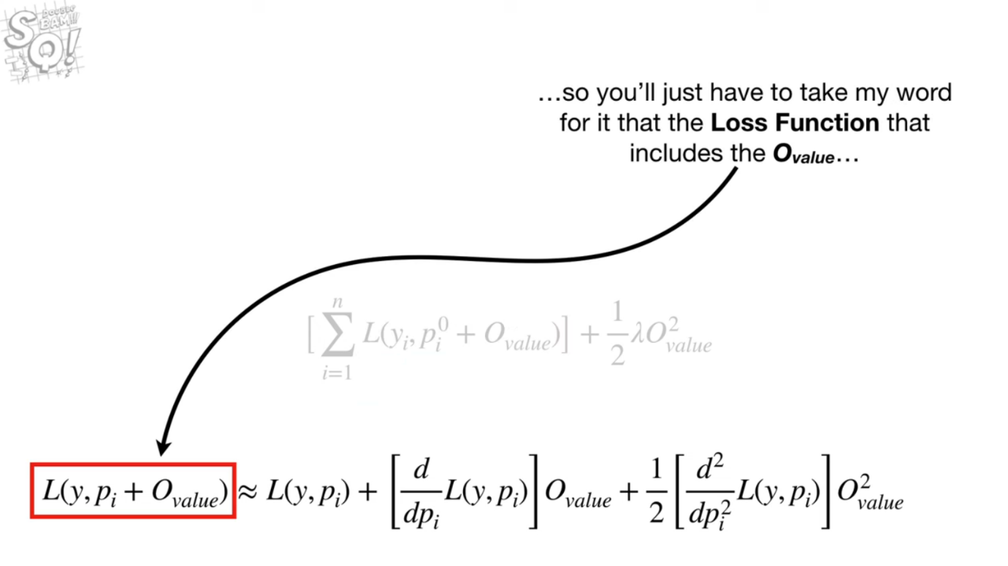

Why XGBOOST is so popular because of these optimizations

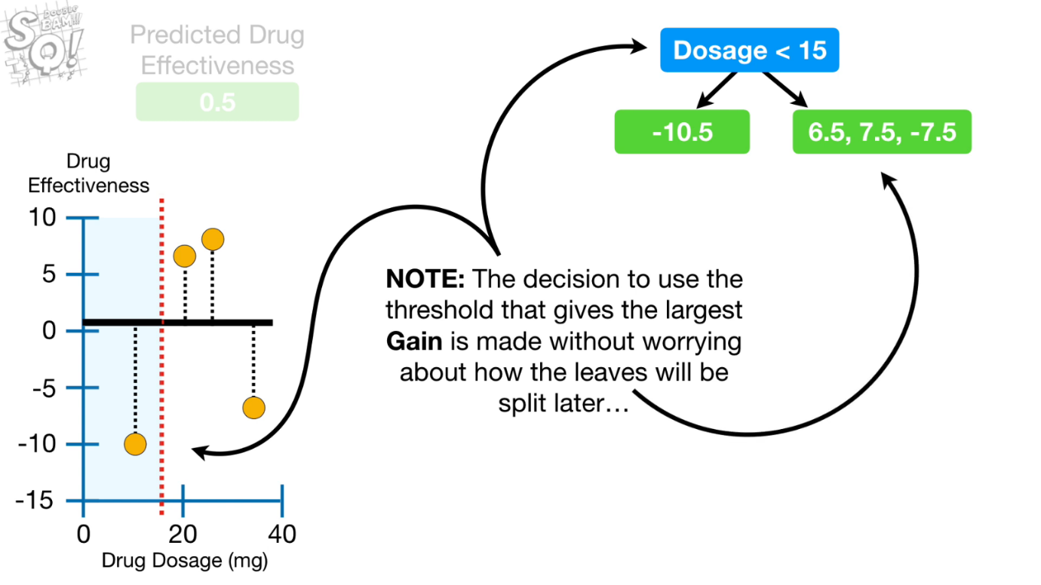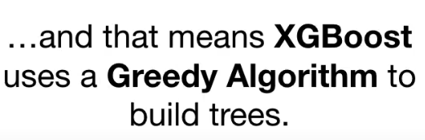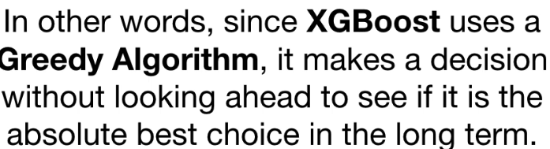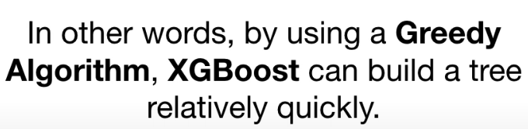

**If we have very large dataset then greedy algorithm becomes slow because it should look at every possible threshold.** Here where the property of XGBOOST comes in i.e. 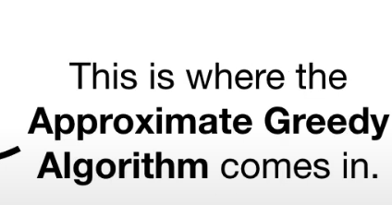

Instead of testing every single threshold we could divide the data into Quantiles. 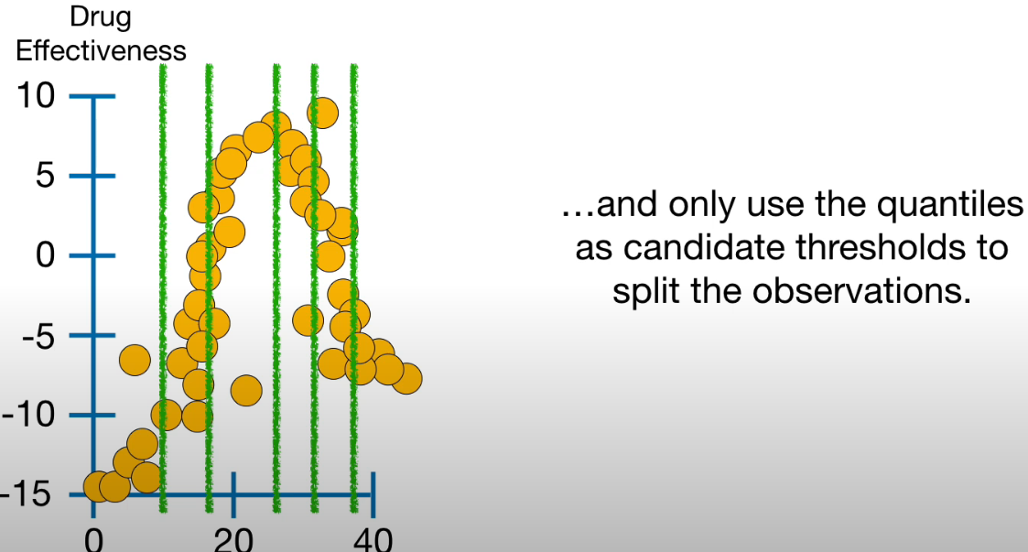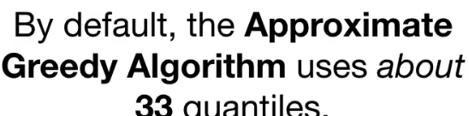

Now the question is why about 35 not exactly 33. To answer this question we need to talk about parallel learning and weighted quantile sketch. when u have tons of data you cannot fit all of it into your computers memory at one time, then things that seem simple, like sorting a list of numbers and finding Quantiles, become really slow. To get around this problem a class of algorithms called Sketches can quickly creates approximate solutions. A small brief about quantile sketch algorithm. Data (split and kept those pieces on different computers on a network).The quantile sketch algorithm combines the values from each computer to make an approximate histogram. Then approximate histogram used to calculate approximate Quantiles and the Approximate Greedy algorithm uses approximate Quantiles. But instead of simple quantiles it do weighted quantiles. Each quantile has fixed weights (sum of the weights in each quantile are equal). The weights are derived from the COVER metric that we discussed earlier. Specifically the weight for the each observation is 2nd derivative of the loss function that we are referring to as the Hessian. That means for Regression the weights are all equal to one and that means the weighted Quantiles are just like normal quantiles and contain a equal number of observations. In contrast for classification the weights are

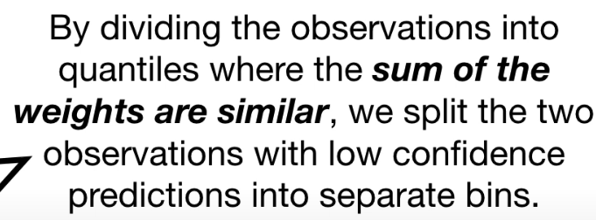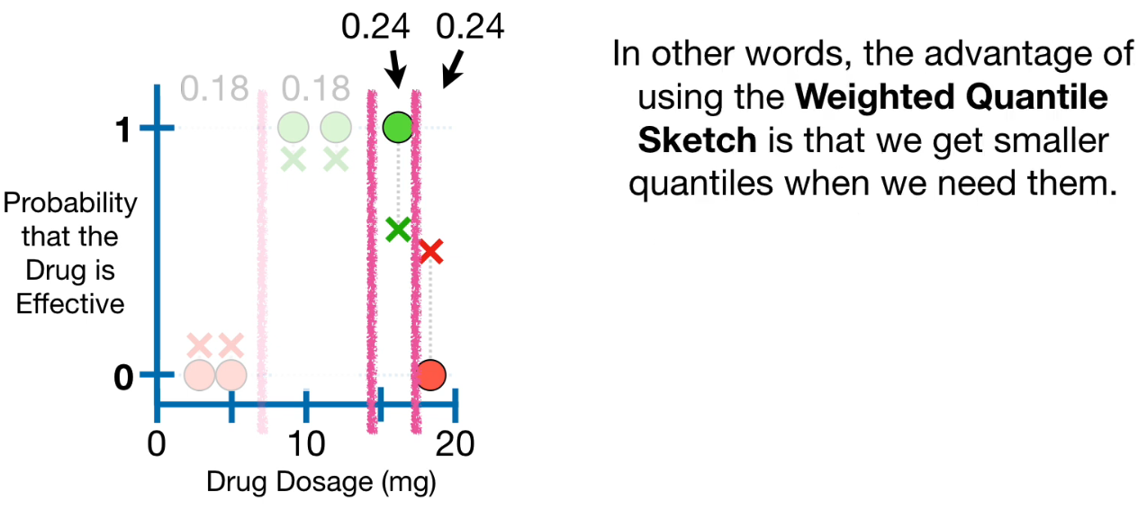

**So when we have Huge training dataset, XGBOOST uses an Approximate greedy algorithm and that means uses parallel learning to split up the dataset so that multiple computers can work on it at the same time, and a weighted Quantile sketch merges the data into an approximate histogram, and the histogram is divided into weighted Quantiles that put observations with low confidence predictions into Quantiles with fewer observations**

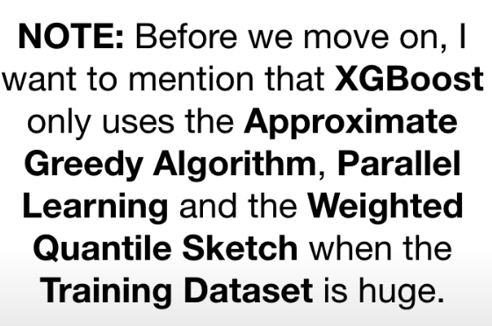

The text you've provided explains that XGBoost, a popular gradient boosting algorithm, employs specific techniques – the Approximate Greedy Algorithm, Parallel Learning, and the Weighted Quantile Sketch – **only when dealing with very large training datasets**.

Let's break down what each of these means and how they are handled in code:

**1. Approximate Greedy Algorithm:**

* **What it means:** In traditional decision tree building, finding the optimal split at each node involves evaluating all possible splits, which can be computationally expensive for large datasets. The approximate greedy algorithm approximates this process by considering only a subset of possible split points. This significantly reduces computation time, especially for massive datasets.
* **In code:** XGBoost automatically switches to the approximate greedy algorithm when the dataset exceeds a certain size threshold. This threshold is usually determined based on the available memory and computational resources. You don't typically need to explicitly set a flag to enable it. XGBoost handles it internally.

**2. Parallel Learning:**

* **What it means:** XGBoost leverages parallel processing to speed up the training process. It can build multiple trees (or parts of trees) concurrently, taking advantage of multi-core CPUs or distributed computing environments.
* **In code:** XGBoost has built-in support for parallel learning. It automatically detects the available hardware resources and utilizes them for parallel computation. You can often control the degree of parallelism using parameters like nthread (number of threads) or by configuring distributed computing settings if you're working in a cluster.

**3. Weighted Quantile Sketch:**

* **What it means:** The quantile sketch is a data structure used to approximate the distribution of data. In the context of XGBoost, it's used to efficiently find candidate split points for the approximate greedy algorithm. The "weighted" part indicates that it takes into account the instance weights (e.g., importance weights) during the approximation.
* **In code:** Similar to the approximate greedy algorithm, the weighted quantile sketch is automatically employed when the dataset is large. You don't need to explicitly enable it. XGBoost handles its implementation internally.

**Do we use special settings for that in code and computer?**

* **Not usually for enabling these techniques directly.** XGBoost is designed to intelligently switch to these efficient methods when necessary based on the dataset size and available resources.
* **However, you can influence the behavior indirectly through parameters:**
  + **max_bin:** This parameter controls the number of bins used for discretizing continuous features during the approximate greedy algorithm. A smaller value leads to faster computation but potentially lower accuracy.
  + **nthread:** As mentioned earlier, this controls the number of threads used for parallel learning.
  + **Memory management:** Ensuring sufficient memory is available can prevent XGBoost from resorting to more aggressive approximations that might impact accuracy.
  + **Distributed computing settings:** If running XGBoost on a cluster, you'll need to configure the distributed environment appropriately.

**In summary:**

XGBoost is designed to be efficient for large datasets. It automatically switches to the Approximate Greedy Algorithm, Parallel Learning, and Weighted Quantile Sketch when the data warrants it. You typically don't need to manually configure these techniques. However, understanding their purpose and how they relate to parameters like max_bin and nthread can help you optimize XGBoost for performance and accuracy on large datasets.

Now lets talk about **Sparsity aware split finding**

**If we have missing values in dataset, we divide the dtata into two tables one with missing values and other with non missing values.now we calculate two separate gain values.**

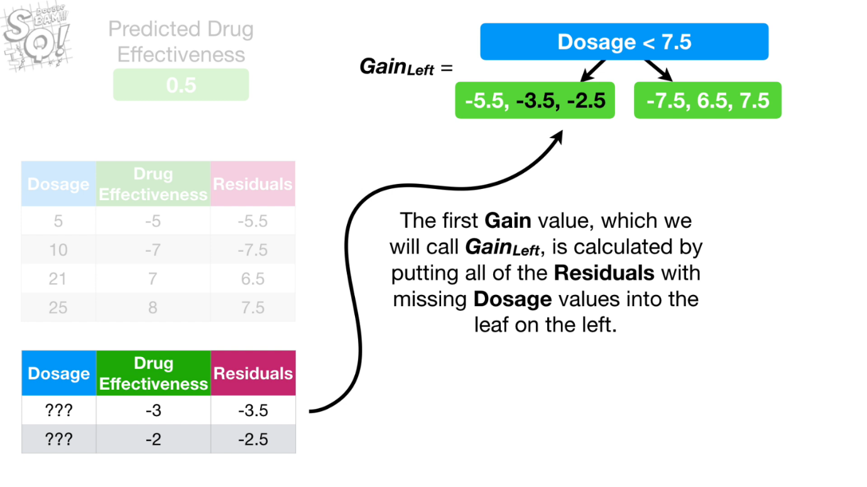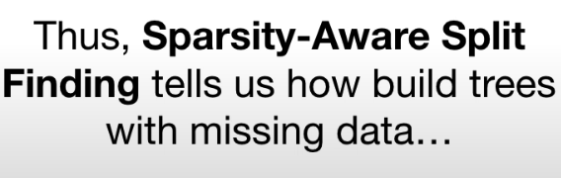

**Cache Aware Access:**

**CPU has a cache memory , cpu uses this memory faster than any other memory in the computer**

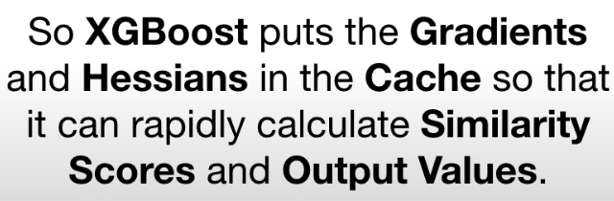

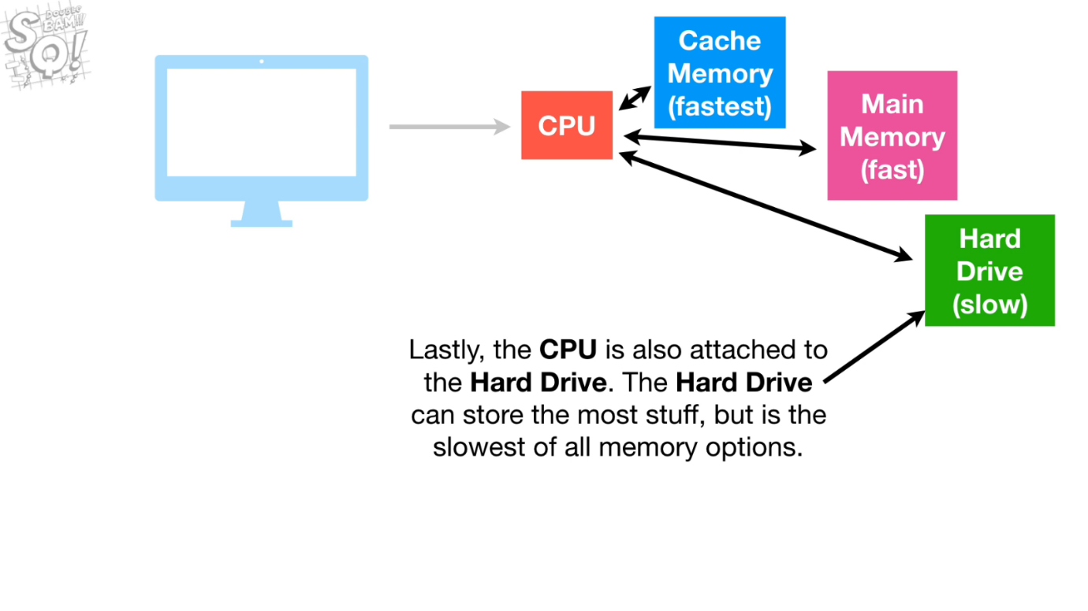

**BLOCKS OUT OF CORE COMPUTATIONS:**

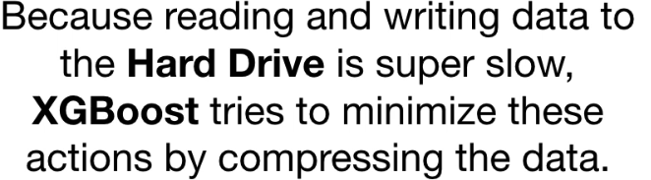

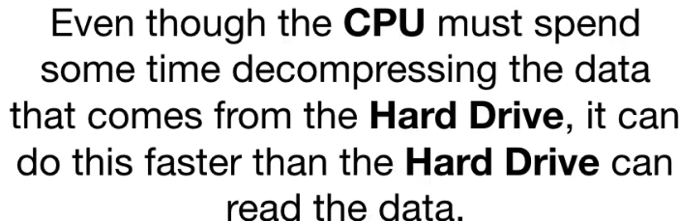

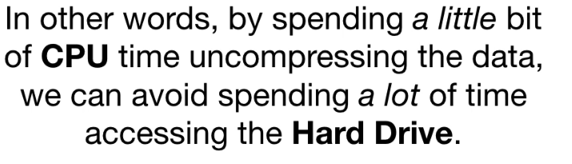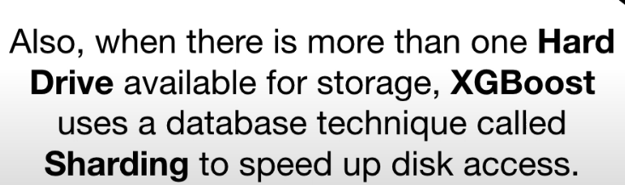



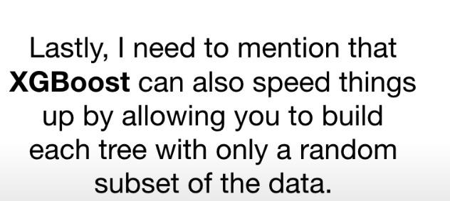

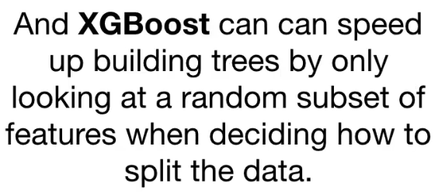

**Because of all these XGBOOST is faster on handling large datasets.**